Room E
EQ1 Arteriovenous Fistula with outflow stenosis
Stem: 58 year old male with end stage renal disease presents to the emergency department with redness and thinning skin overlying his left brachiocephalic arteriovenous fistula. You are called to see the patient emergently because of reports from the dialysis center that they had difficulty stopping the bleeding from one of the sites after dialysis earlier today. The ER physician has outlined the areas that she is concerned with.
PMH:
ESRD, HTN, medullary cystic GN,
PSH:
Left AVF, Appendectomy as a child
Medications:
Amlodipine, calcitriol, atorvastatin
Physical Exam:
Temp 99.5
HR 102
RR 21
BP 185/87
GEN: Alert and oriented x3
EXT: Left AVF is very pulsatile but has a component of a thrill with an audible bruit. There are three areas of aneurysmal dilation two of which have some associated erythema (as seen in the picture).
Labs:
WBC 14K; H/H 9/27: PLT 270K
CO2 18, CR 5.7, K 4.9.
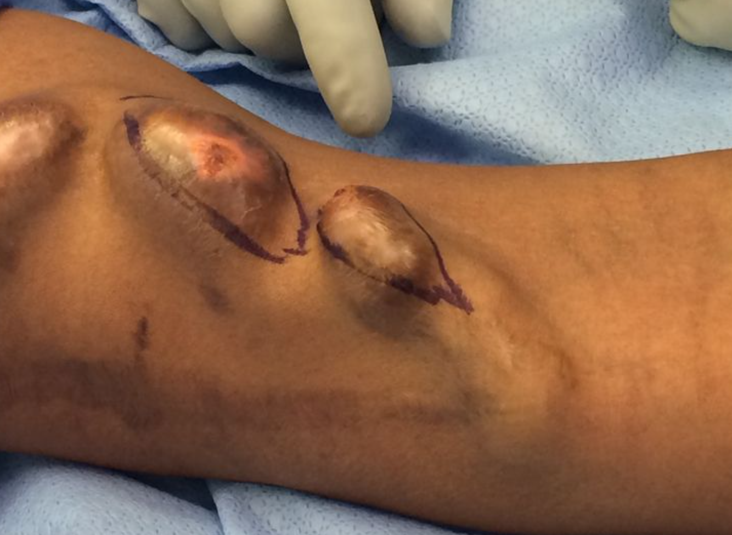
Note the scab over the puncture site and the very thin, erythematous skin.

How would you manage this patient?
- Admit the patient.
- dose of antibiotics (Ancef or Vancomycin)
- type and cross for two units of blood.
- perform a fistulogram and balloon angioplasty to alleviate the almost certain outflow stenosis.
Pitfall! If they attempt to operate on this patient without first managing the outflow: Alter the scenario such that they are then in the operating room and once they make an incision, explain that the cannulation site is now bleeding profusely with the blood hitting the ceiling. Did they place a surgical tourniquet after they prepped the arm? How will they get proximal and distal control?
- (Note: Patients with long standing, high flow arteriovenous fistulas develop outflow or central venous stenosis secondary to venous intimal hyperplasia (caused by the turbulent blood flow). Attempting surgical intervention, without first treating the outflow stenosis can lead to uncontrolled hemorrhage.)
  - place tourniquet above the area of cannulation.
  - procedure should be performed using fluoroscopy.
  - perform micropuncture cannulation of fistula.
  - exchange to 7Fr sheath over guidewire.
  - perform angiogram.
  - identify site of stenosis.

    - 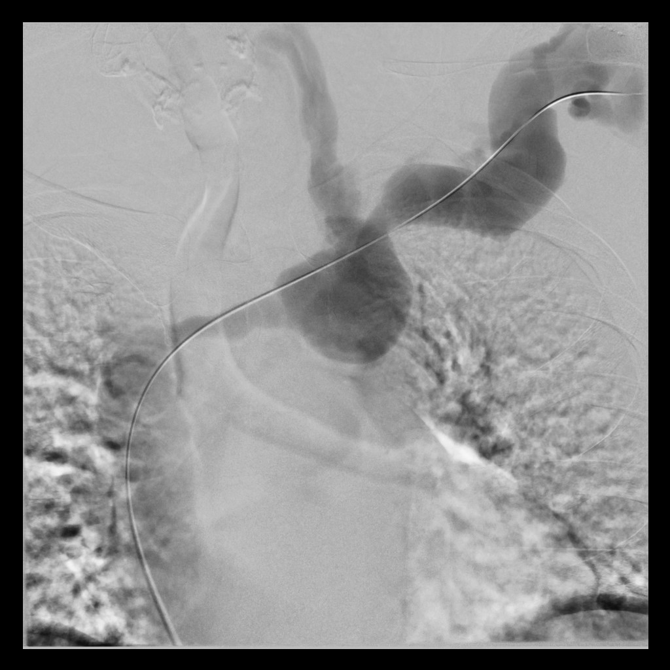
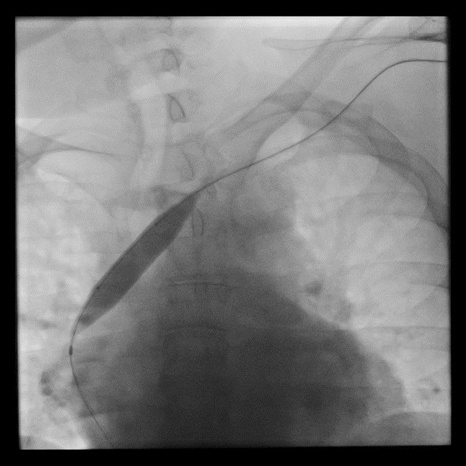
On the fistulogram, the examinee should note the contrast refluxing up the left internal jugular vein (suggesting outflow stenosis) and the narrowed innominate vein, central to the left internal jugular vein.
  - place guidewire across area of stenosis.
  - advance angioplasty balloon over guidewire.
  - perform balloon angioplasty.
  - perform completion angiogram.
  - Once the outflow stenosis has been treated, excise aneurysmal section
    - excise the anterior wall of aneurysmal sections
    - repair the fistula wall primarily (2 layers - running horizontal mattress followed by an anterior running simple layer; 3-0 or 4-0 prolene suture).
    - The subcutaneous tissue and the skin should be closed over the top.
    - Some may opt to do a bypass of this area with a PTFE or bovine graft and this is an acceptable surgical option.

Pitfalls:
- Not performing fistulogram before proceeding to OR.
- Not Using torniquet.
- Trying to put stitch in ER in the weak point of the AVF.

Reference:
- https://www.ncbi.nlm.nih.gov/pmc/articles/PMC4515897/

EQ2 Breast Scenarios DCIS/LCIS/Ductal Papiloma.

Stem: 55y postmenopausal female is referred to the office for calcifications seen in the upper outer quadrant of the left breast on annual screening mammogram that weren’t appreciated on the mammogram the year prior. She denies any changes in her breasts or axillae.
Her physical exam is unremarkable.
Family history is negative for breast or gynecologic malignancies.
No past medical or surgical history

What is your Differential Dx?
- DCIS
- LCIS
- Invasive breast cancer
- Atypical ductal or lobular hyperplasia
- Fibrocystic changes
- Fat necrosis

Additional Workup or Studies?

- Diagnostic mammogram reveals fine linear branching calcifications located near the chest wall in the upper, outer quadrant of the left breast; the calcifications appear focal and do not appear to be multicentric
- Stereotactic core needle biopsy returns as DCIS

What would you like to do now?
- Surgery:
    - Localization
    - Breast conserving surgery with postoperative radiation (no SLNB)
    - (or) Simple mastectomy with sentinel lymph node biopsy +/- reconstruction

Pathology returns as ER/PR + high grade DCIS, what treatment you would recommend ?
5 years of anastrozole

Scenario 1: Same patient, but core needle biopsy returns as LCIS (ER/PR +, HER2/neu negative). You proceed to OR for excisional biopsy, Pathology returns LCIS, positive inferior margin

What would you like to do now?

- Observation:
- H&P q6 months x5y
- Mammogram in 6 months then annually
- Anastrozole or raloxifene

- bilateral prophylactic mastectomy +/- reconstruction, however usually reserved/recommended for patients with strong family history and/or high genetic risk.

(To examiner: Examinee should recognize that LCIS is a marker of increased risk but not an actual precursor lesion therefore -no tumor on ink- does not apply)

Scenario 2: Different 55y. postmenopausal female presenting with complaints of unilateral bloody nipple discharge from the left breast. Mammogram is unremarkable.

What would you like to do now?

- Ultrasound vs MRI vs contrast ductography: US demonstrated a dilated duct in the left periareolar area
- Ultrasound guided biopsy: indeterminate

- OR: Terminal duct excision/excisional biopsy: insert a fine lacrimal duct probe into the dilated duct, make a periareolar incision (no more than 30% circumference), isolate the affected duct and resect the subareolar region with the abnormal duct attempting to preserve unaffected duct(s) if possible.

- Pathology: intraductal papilloma

EQ3 Gallstone Ileus
Stem: A 76-year-old demented woman presents to the emergency department from her nursing facility with 4 days of intermittent abdominal pain, confusion, food intolerance, emesis and diminished urinary output.
Past medical history includes Alzheimer’s dementia, COPD, CAD, HTN, cholelithiasis, HLD.
Past surgical history includes total abdominal hysterectomy.
Examination: HR 110bpm, BP 106/43mmHg, 92% sats on room air, 36.6C. Abdomen is distended and tympanic however soft, with generalized tenderness without involuntary guarding or signs of peritonitis.

Pertinent labs: WBC of 12.4, LA 2.4, NA 130, Chloride 92. LFTs, lipase and amylase are within normal limits.

What study would you order?

- Abdominal xray
- CT scan

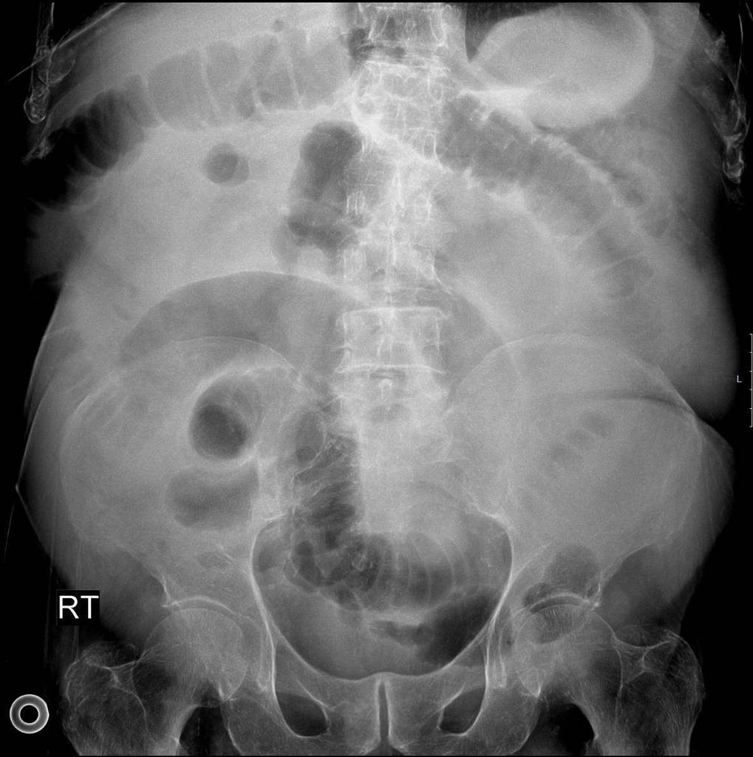

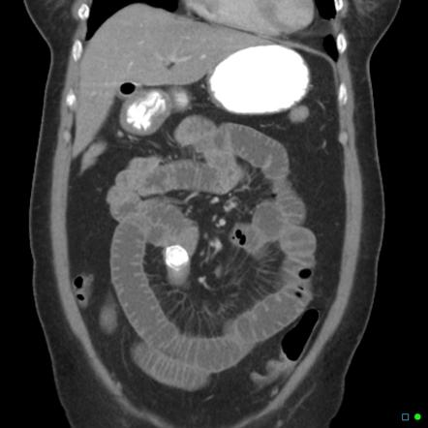

What is your differential diagnosis?
- Small bowel obstruction
- Gallstone ileus
- Mesenteric ischemia
- Intestinal perforation
- Malignancy

What would you like to do now?
- NGT decompression
- IV access
- Resuscitation.

Recognition of gallstone ileus on imaging
- OR for ex-lap
  - Inspect/palpate entire midgut
  - Longitudinal enterotomy, stone extraction and closure in H-M fashion

How do you mange cholecystoenteric fistula?
leave it alone in old, frail and sick people

Scenario 1: Same patient, however, you are unable to milk the stone out proximally.
Perform a segmental small bowel resection.
Scenario 2: Same patient successfully treated with enterotomy with stone retrieval and primary closure of the small bowel. In the coming days becomes increasingly tachycardic, febrile, and hypotensive.

What is you diagnosis? How would you manage?
Enteric leak
- IVF resuscitation.
- Empiric abx.
- If stable CT
- Versus Immediate return to OR

Scenario3: Gallstones ileus identified in a 60-year-old farmer with history of HTN and HLD, otherwise physically active and relatively healthy.
What would you do with the gallbladder and cholecystoenteric fistula in this setting?

- Explores gallbladder and identifies whether there are residual stones
- If patient is stable and can undergo long procedure would be acceptable to perform cholecystectomy and closure of cholecystoenteric fistula at time of surgery, otherwise perform as staged procedure.
- At time of cholecystectomy, performs cholangiogram to ensure CBD exploration does not need to be performed.

Describe how to repair the duodenum?
Debride edges if needed, assess posterior wall and ampulla, primary repair transversely to avoid stricture. Protection of repair: buttress with omental fat/falciform, serosal flap. JP drain.

Pitfalls:
- Not recognizing high risk of fistula take down in acute setting.
- Not performing cholangiogram at time of surgery to rule out need for CBD exploration.
- Not knowing rule of fistula staged take down or at time of surgery IF appropriate.

